**Table of Contents**

Section 1.0 Introduction ……………………………………………………………3

1.1 Purpose………………………………………………………………... 3

1.2 Scope of Project………………………………………………………..3

1.3 Glossary…………………………………………………………………3

1.4 References……………………………………………………………...4

1.5 Overview………………………………………………………………...4

Section 2.0 Overall Description…………………………………………………….4

Section 2.1 System Environment………………………………………….4

Section 2.2 Functional Requirements…………………………………….5

Section 2.2.1 Use Case: Clinician………………………………………...5

Section 2.2.2 Use Case: Administrator…………………………………...6

Section 2.2.3 Activity Diagram……………………………………………..6

Section 2.3 User Characteristics…………………………………………..7

Section 2.4 Nonfunctional Requirements…………………………………7

Section 3.0 Specific Technical Requirements…………………………………….8

Section 3.1 External Interface Requirements…………………………….8

Section 3.2.1 Patient Search……………………………………………….8

Section 3.2.2 Template Management……………………………………..9

Section 3.3.1 General Constraints………………………………………..10

Section 3.3.2 Assumptions and Dependencies………………………….11

Section 3.3.3 User Input and Validation………………………………….11

Section 3.3.4 Performance Requirements……………………………….11

Section 3.3.5 Design Constraints…………………………………………11

Section 3.3.6 Security……………………………………………………...11

# Section 1.0 Introduction

### 1.1 Purpose

The purpose of this document is to define the initial requirements and constraints of the client for the deployment of a *Patient Like Mine* (PLM) search specific to Mayo Clinic, Rochester, Minnesota. This document outlines the functions of the software as well as the expected outcomes through use case diagrams. This software requirements specification (SRS) document is intended to be used by Mayo Clinic Rochester stakeholders contributing to the development and deployment of PLM.

### 1.2 Scope of Project

This project ultimately aims to develop a system, PLM, utilized by Physicians, Administrators and Researchers with the architecture allowing for a wide range of users. This software will initiate a search to identify patients that are similar to a certain patient of interest or a cohort of patients for both offline and near-real time clinical decision support on a large scale, using data distribution and integration frameworks and rule engines.

The ability to recognize and successfully manage post surgical complications is essential for any surgeon. PLM can improve surgical management by developing a system similar to a clinical decision support system (CDSS) but with the capacity for proactive and reactive support. Proactive support of PLM would allow for predictive outcomes to physicians treating patients. Reactive support of PLM would allow researchers to gather cohort information of a particular type of patient.

Currently, Mayo Clinic Rochester has a database that contains approximately 5,000 patients for postoperative colorectal surgery; therefore, for this pilot project we have selected postoperative colorectal surgery patients as our cohort. The most frequent postoperative complications with colorectal resections are surgical site infection, anastomotic leakage, intra-abdominal abscess, ileus and bleeding (2). These complications need to be diagnosed accurately as they affect patient outcome. For the scope of this project, we have selected post-surgical bleeding for the complication of interest. PLM searches will allow comparisons of bleeding *parameters* of the patient of interest with previous outcomes, with the potential capability of predicting a post-surgical bleed. The physician would have the ability to search pre or post operatively patients with similar parameters; however, for this project, we have selected post op day 2 for our search criteria.

PLM searches will be achieved by taking a wide range of complex data, defined by a template, that enable searches (queries) to extract and render relevant data visually.

### 1.3 Glossary

|  |  |
| --- | --- |
| Term | Definition |
| Physician | Surgeon or other speciality medical doctor treating the patient |
| Administrator | Individual that has the ability to modify, add, remove templates |
| Patient | Individual who is post-operative day 2 colorectal surgery |
| Template | Collection of search criteria that defines patients of interest in the search. Includes an input and output template. |
| Input Template | Defines the similarity criteria between patients such that further analysis will only be performed on patients that are determined to be ‘similar’ to the initial patient of interest.  Such fields in this template would include attributes, relative weight of attribute, relative time of attribute, multi-value selector, and range/boundary of attribute |
| Attribute (see Input Template) | Element or variable of interest taken from patient information.  For our bleed template example such elements would be, but are not limited to, Hemoglobin, heart rate, blood pressure, height, weight, gender, race, address, etc. |
| Relative Weight of Attribute (see Input Template) | The weight applied to attribute when defining similarity. |
| Relative Time of Attribute (see Input Template) | The time range applied to attribute relative to event when defining similarity.  Such time ranges could include post-op day 1, 2, …, n, pre-op year 1, etc. |
| Multi-Value Selector (see Input Template) | The desired value of an attribute when defining similarity.  Such values can include any, first, maximum, minimum, last, arithmetic mean, median, etc. |
| Range/Boundary of Attribute (see Input Template) | The desired range of an attribute when defining similarity.  Such ranges can include percent range, percentile range, edit distance, ontological distance, etc. |
| Output Template | The variables that are extracted from the group of ‘similar’ patients which are used to define the likelihood of developing the condition (bleed).  Such fields in this template would include attributes, relative time of attribute, and multi-value selector. |
| Attributes (see Output Template) | Element or variable of interest from patients similar to the current patient.  For our bleed template example such attributes could include reoperation, blood transfusion, bleed order set, etc. |
| Relative Time of Attribute  (see Output Template) | The time range of attribute relative to event of patients similar to current patient.  Such ranges include post op day 1, 2, 3, …, n. |
| Multi-Value Selector (see Output Template) | The desired value of an attribute of patients who are found similar to current patient.  Such values could include any, total, etc. |
| “Patient Like Mine” (PLM) Search | Search algorithm that finds patients with similar characteristics to a patient of interest from an existing patient database |
| Patient Database | Pre-existing database within the Electronic Medical Record (EMR) system |
| “Patient Like Mine” (PLM) System | System independent of EMR that performs analytics on the patient retrieved from the database and displays the results to the physician |

### 1.4 References

1. IEEE. IEEE Std 830-1998 IEEE Recommended Practice for Software Requirements

Specifications. IEEE Computer Society, 1998.

1. *Complications in colorectal surgery: risk factors and preventive strategies.* **Kirchhoff, Clavien and Hahnloser.** 5, s.l. : Patient Safety in Surgery, 2010, Vol. 4.

### 1.5 Overview

The remainder of this document will include all functional and nonfunctional requirements, user-diagrams, constraints associated with the system will be listed in addition to any constraints on the system. This SRS is organized by sections with Section 2 containing the overall description of the system and Section 3 containing the Specific Technical requirements.

# 

# Section 2 Overall Description

## Section 2.1 System Environment

The *PLM* system will primarily focus on patients that are not easily identified as having a bleed post-colorectal surgery. The primary actors who will utilize the PLM system will be clinician, who initiate the search, and administrators, who edit the search templates used by the physicians. Figure 1, below, displays the overall design of the system.

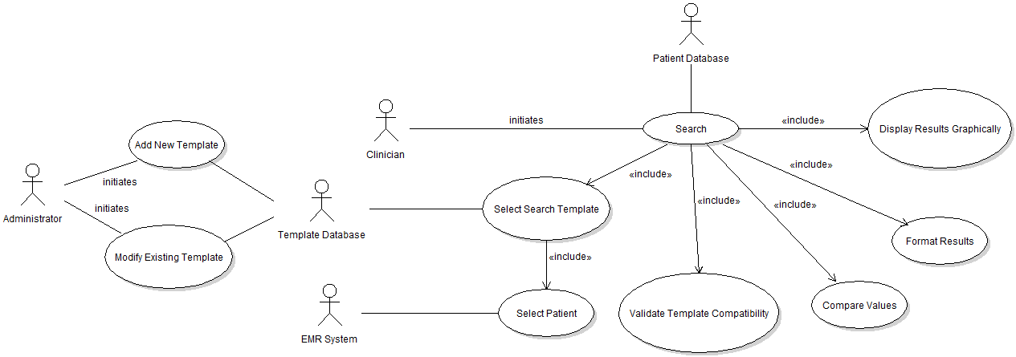

Figure 1: PLM System Overview

## Section 2.2 Functional Requirements

This section will provide an overview of each of the use cases outlined above. The physician is the primary actor for the PLM system.

### Section 2.2.1 Use Case: Clinician

In this use case (figure 2 below), the clinician initiates the system by selecting the search function within the PLM system. Selecting this search function includes the selection of a search template as well as the selection of a patient of interest. The template is pulled from a search template database within the PLM System while the list of selectable patients is pulled from the EMR system. The selection of the patient of interest must be done prior to selecting the search template, as the patient’s data may be used to inform which templates are available. Once both the template and patient have been selected, the system checks that the selected template can logically be applied to the selected patient or cohort. After this validation, the system initiates the PLM search algorithm which calls to the EMR’s patient database and extracts a cohort of patients who were in the same medical situation as the patient of interest (Post-OP Day 2 of Colorectal Surgery). Analytics are then performed on this extracted cohort based on the complication criteria defined in the search template (Bleed Complication). Once similarity is determined between the cohort and the patient of interest, the results are then organized and presented graphically to the clinician.

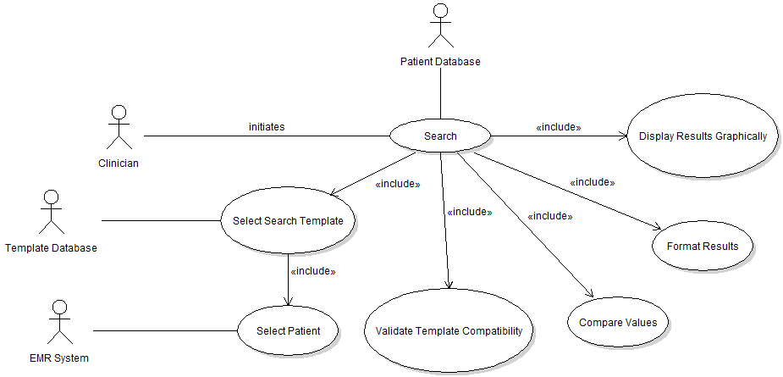

Figure 2: Clinician Use Case

### Section 2.2.2 Use Case: Administrator

In this use case, the administrator either includes a new search template to the template database or modifies an existing template in the template database. The template database is stored within the PLM System (shown in figure 3 below).

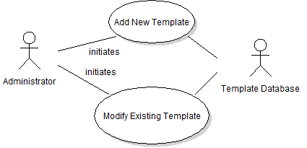

***Figure 3: Administrator Use Case***

### 

### Section 2.2.3 Activity Diagram

Figure 4 below describes the clinician’s use case in more detail.

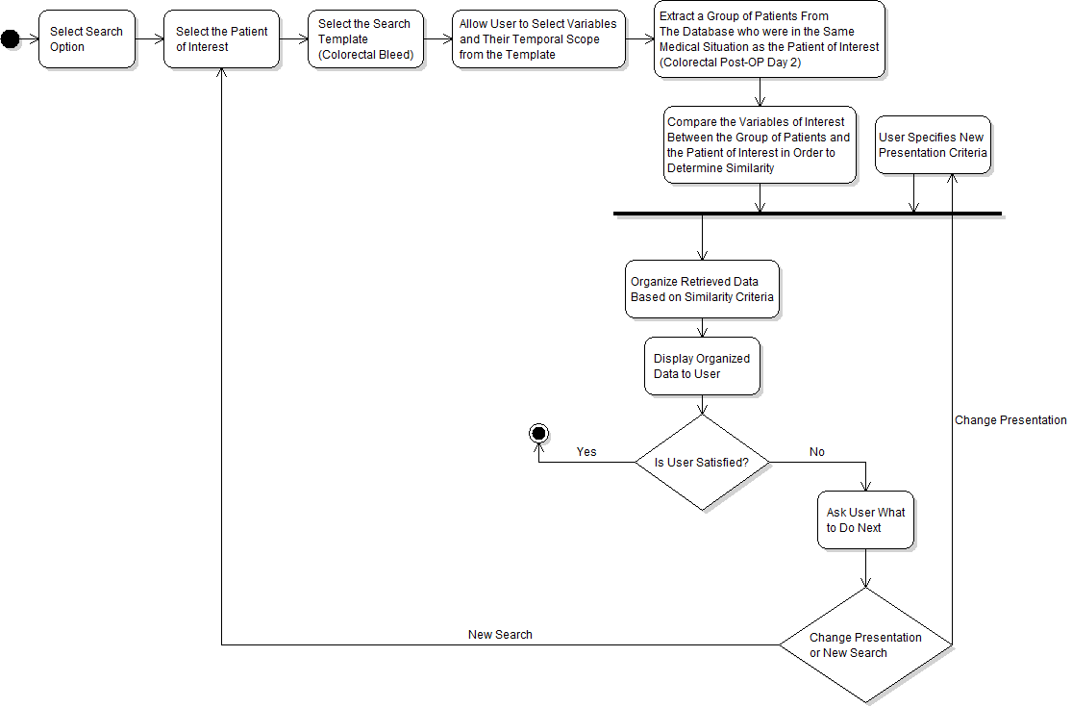

Figure 4: Activity Diagram from Perspective of Clinician

### Section 2.2.4 Sequence Diagram

The sequence diagram in figure 5 below describes the interactions between the clinician and the various systems in play.

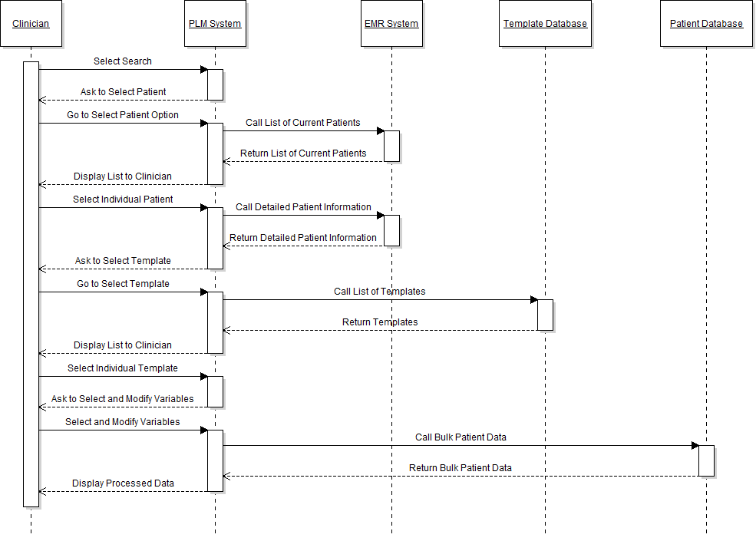

Figure 5: Sequence Diagram for the PLM System

## Section 2.3 User Characteristics

The clinician should be familiar enough with the PLM System to be able to access it outside of the EMR system. They must also be familiar with the variables used in the search templates. In addition to knowing the variables used in the search templates, the clinician needs to be familiar with the graphical representation of information the PLM system will generate.

The administrator must be familiar with medical terminology and processes to follow during complications in order to properly develop and edit the search templates.

## Section 2.4 Nonfunctional Requirements

The PLM system will be housed on a server at Mayo Clinic - Rochester. This server will have the ability to communicate with the patient database and the EMR. It is assumed that the patient database will be pre-existing within the EMR prior to the implementation of the PLM system.

The PLM system must be available to the clinician when the EMR system is accessed. The administrator will have access to the PLM system without requiring access to the EMR.

# 

# Section 3 Specific Technical Requirements

## Section 3.1 External Interface Requirements

Currently, there is no such PLM search system in place at Mayo Clinic Rochester. In order for such a patient search system to exist externally of the EMR the PLM system needs to communicate with the EMR. It is advantageous to keep the PLM system external to the EMR to alleviate the system load the EMR bears. Users will interact with PLM system via desktop computer environment which typically includes keyboards, mouse as well as from graphical user interface on the users PC.

**Section 3.2 Detailed Description of Functional Requirements**

This section presents a requirement overview of the PLM system. The PLM system will be developed using the necessary software languages required.

System activity is subdivided into two primary functions. The first activity will be the patient search. The second activity will be template management/modification.

### Section 3.2.1 Patient Search

The clinician will be able to initiate a search based on a specific patient. The search will display results to the clinician upon final execution.

|  |  |
| --- | --- |
| **UseCaseID:** | Patient Search |
| **Goal In Context:** | To search for patients similar to a patient of interest |
| **Scope:** | PLM System |
| **Pre-Condition:** | The actor has successfully accessed the PLM system (external of EMR) |
| **Success End Condition:** | Search results are displayed to the actor |
| **Failed End Condition:** | The search cannot be completed |
| **Primary Actor:** | Clinician |
| **Trigger Event:** | The “Patient Like Mine” Button is pressed |

**Main Success Scenario**

|  |  |  |
| --- | --- | --- |
| Step | Actor | Action Description |
| 1 | Clinician | The “Patient Like Mine” button is pressed |
| 2 | Clinician | Select the patient of interest |
| 3 | Clinician | Select the search template |
| 4 | PLM System | PLM system executes search based on search template |
| 5 | PLM System | Patients retrieved based on search template |
| 6 | PLM System | Retrieved patients compared against patient of interest for similarity |
| 7 | PLM System | Organize the results based on similarity |
| 8 | PLM System | Results are displayed to Clinician |
| 9 | Clinician | Clinician accepts results |

**Scenario Extensions**

|  |  |  |
| --- | --- | --- |
| Step | Actor | Action Description |
| 9a | Clinician | Selects different formatting option |
| 9a.1 | PLM System | Return to step 7 |
| 9b | Clinician | Initiates a new search |
| 9b.1 | PLM System | Return to step 3 |

### Section 3.2.2 Template Management

The administrator will be able to access the search template database. Once accessed, the administrator will be able to modify an existing template or add a new template to the search template database.

|  |  |
| --- | --- |
| **UseCaseID:** | Template Management |
| **Goal In Context:** | To modify or add search templates to the template database |
| **Scope:** | PLM System |
| **Pre-Condition:** | The actor has successfully accessed the PLM system (external of EMR) |
| **Success End Condition:** | The search template is successfully modified |
| **Failed End Condition:** | The search template is not successfully modified |
| **Primary Actor:** | Administrator |
| **Trigger Event:** | The “Modify Templates” Button is pressed |

**Main Success Scenario**

|  |  |  |
| --- | --- | --- |
| Step | Actor | Action Description |
| 1 | Administrator | The “Modify Templates” button is pressed |
| 2 | Administrator | Select “Modify Existing Template” |
| 3 | Administrator | Enters modified information |
| 4 | Administrator | Confirms modifications |
| 5 | PLM System | Updates template database |

**Scenario Extensions**

|  |  |  |
| --- | --- | --- |
| Step | Actor | Action Description |
| 2a | Administrator | Selects “Add New Template” |
| 2a.1 | Administrator | Enters new information |
| 2a.2 | PLM System | Return to step 4 |
| 2b | Administrator | Selects “Remove Template” |
| 2b.1 | Administrator | Select template to remove |
| 2b.2 | PLM System | Return to step 4 |

## Section 3.3 Detailed Non-Functional Requirements

### Section 3.3.1 General Constraints

Results from patient search could potentially be large. Standards need to be in place to define ‘similarity’ between certain variables. For example, a multi-value variable such as hemoglobin would be optimally represented as an average of the three values instead of disparate measurements. Trends in data with multiple data points across time would need to be identified. In the future, the system will be scalable such that additional templates beyond colorectal surgery could be added.

### Section 3.3.2 Assumptions and Dependencies

It will be assumed the patient database will be in place before the implementation of PLM system. EMR and PLM system will be able to interact. Software required to produce graphical representation of results is assumed to be available.

### Section 3.3.3 User Input and Validation

The search cannot execute unless user selects a patient and search template.

### Section 3.3.4 Performance Requirements

PLM system will have sufficient memory to extract and store a potentially large set of patient information. CPU fast enough to perform analytics on patient information in ‘near-real’ time.

### Section 3.3.5 Design Constraints

The PLM system will primarily focus on patients that are not easily identified as having a bleed post-colorectal surgery. This system will query an existing patient database using a template. Upon completion of the query the results will present the information graphically to the clinician. This project will aid clinicians in determining if a patient has a bleed post-colorectal surgery.

### Section 3.3.6 Security

Only individuals at Mayo Clinic Rochester designated as administrators will have access to the search template database to modify the database. Furthermore, clinicians will not have direct access to the template database, only indirectly through the search function. The firewall system through Mayo Clinic will ensure appropriate security for the user’s connection. In addition, the firewall system will ensure appropriate security for the connection between the PLM system and the patient database.